Week3 Day1 assignment
Playwright typescript code implemented
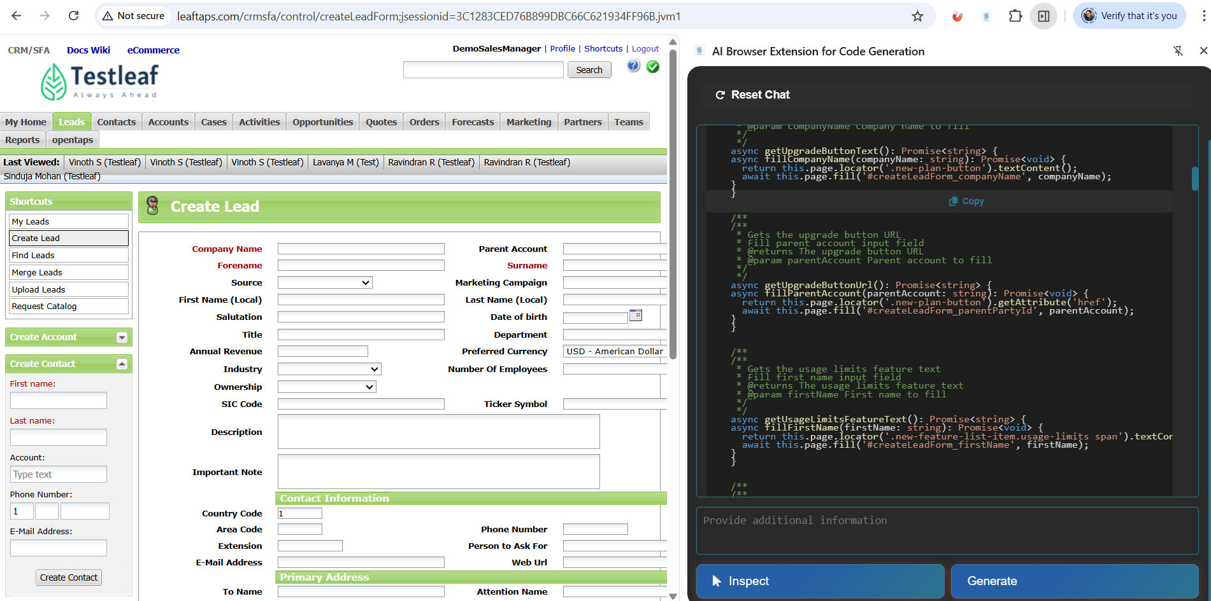
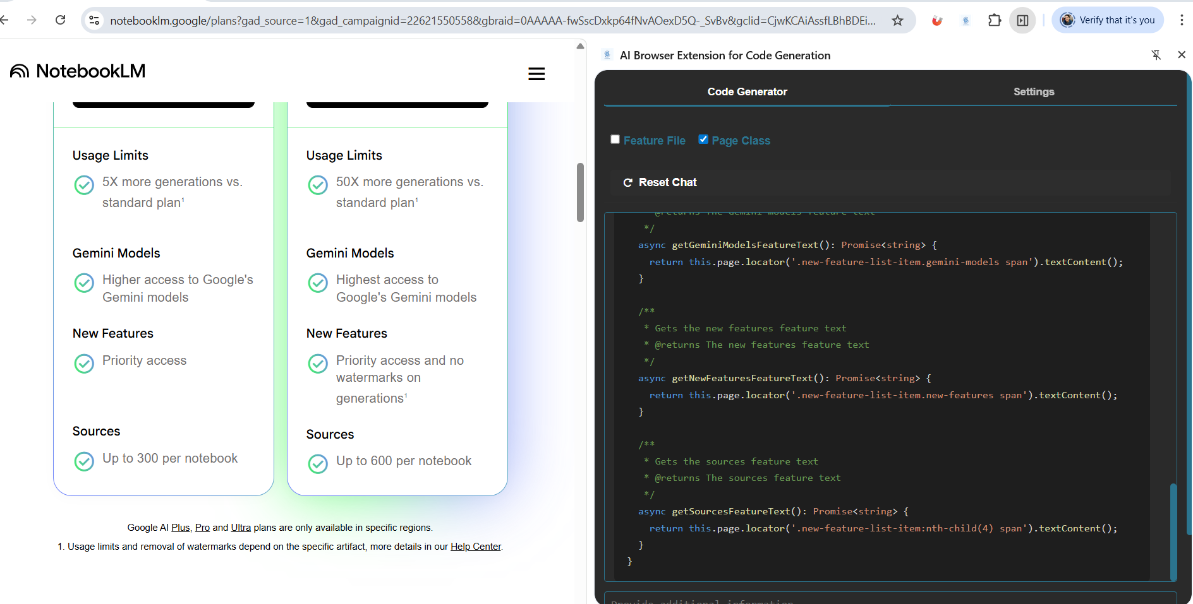

Week3 Day 2
Assignment- 1
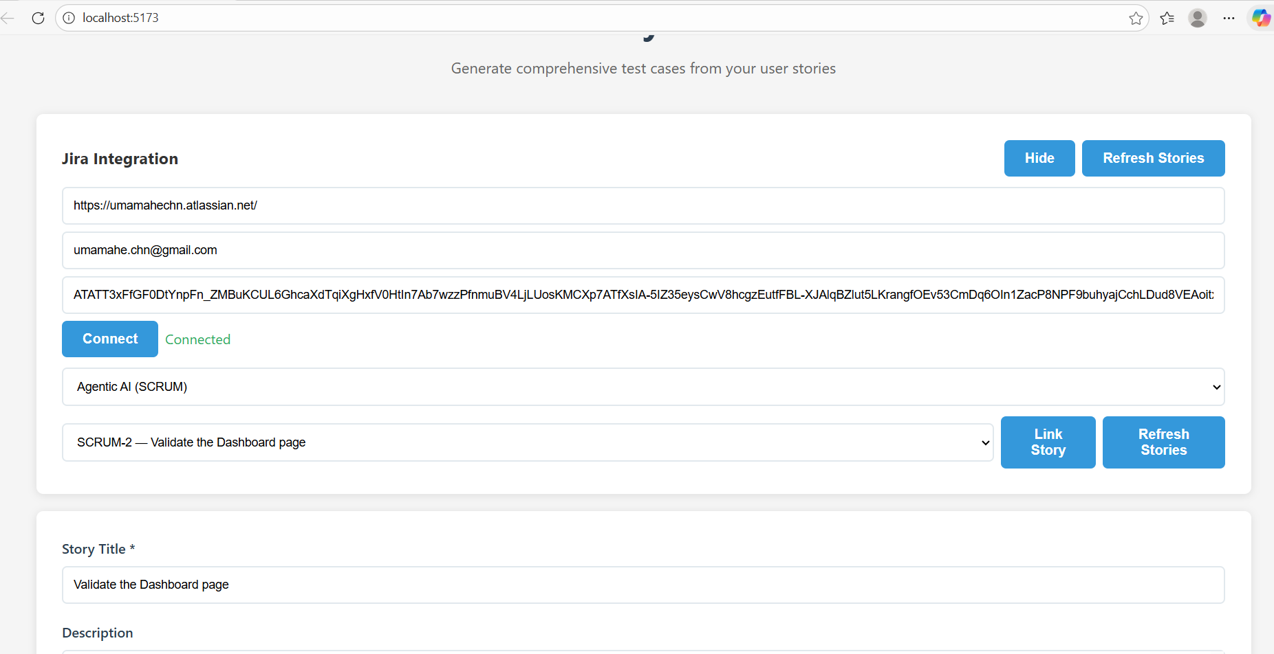

Based on the workspace structure, the files changed as part of Jira integration are:
- jira.ts - New file
  - Implements all Jira API endpoints (/connect, /projects, /stories, /story/:key)
  - Handles Jira authentication and multiple JQL query variants
  - Fetches projects, stories, and individual story details
- server.ts - Modified
  - Added import for jiraRouter from ./routes/jira
  - Registered Jira routes with app.use('/api/jira', jiraRouter)
- api.ts - Modified
  - Added connectJira() function to connect to Jira
  - Added fetchJiraProjects() function to fetch available projects
  - Added fetchJiraStories() function to fetch stories for a project
  - Added fetchJiraStory() function to fetch individual story details
- App.tsx - Modified
  - Added Jira connection state management (multiple useState hooks for Jira config, connection status, stories, etc.)
  - Added Jira integration UI section with connect form
  - Added project selector dropdown
  - Added story selector and "Link Story" button
  - Added handlers: handleConnectJira(), handleLoadStories(), handleLoadStoriesForProject(), handleLinkStory()
These changes enable users to connect their Jira instance and import user stories directly into the test generation form.

Assignment -2 : Add a download button in UI with the formats like XLSX,PDF,CSV.

Prompt used:
Read my entire workspace and understand how UI and backend implementation is done.
Add a download button in UI with the formats like XLSX,PDF,CSV.
Once test cases were generated, I should be able to download them using any one of the format SUCCESSFULLY. Make necessary changes

AI results:
Next steps for you (run these in your workspace terminal):
- Start the backend dev server:
- cd backend
- npm install
- npm run dev

- In the frontend (if not already running):
- cd frontend
- npm run dev

- Open http://localhost:5173, generate test cases, and try the Download buttons.

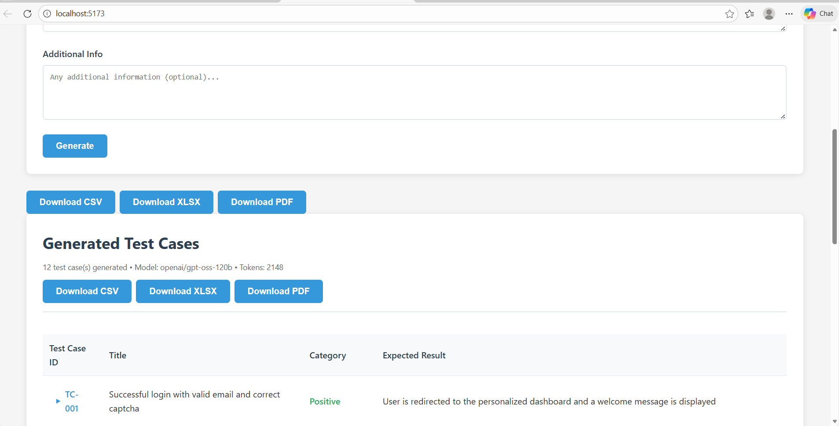

Downloaded test cases in XLSX format

